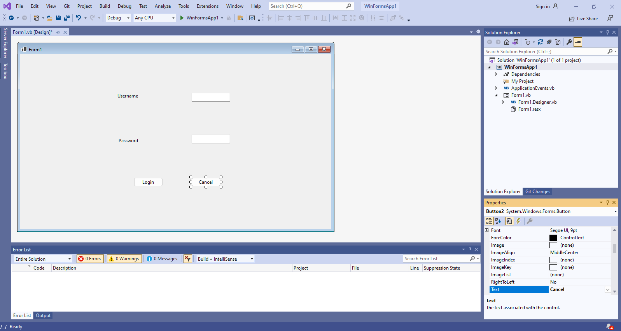

Imports System.Data.SqlClient

Public Class Form1

Private Sub Button1_Click(sender As Object, e As EventArgs) Handles Button1.Click

Try

Dim oc As New SqlConnection

Dim dr As SqlDataReader

Dim cmd As New SqlCommand

oc.ConnectionString = "Data Source=22CTIT08;Initial Catalog=Studentdb;User ID=sa;Password=sql"

cmd.Connection = oc

oc.Open()

cmd.CommandText = "select username, password from login where username='" & TextBox1.Text & "'and password='" & TextBox2.Text & "' "

dr = cmd.ExecuteReader

If dr.HasRows Then

Form2.Show()

Else

MessageBox.Show("Invalid username or password")

End If

oc.Close()

Catch ex As Exception

MessageBox.Show(ex.Message.ToString())

End Try

End Sub

Private Sub Button2_Click(sender As Object, e As EventArgs) Handles Button2.Click

Me.Close()

End Sub

End Class

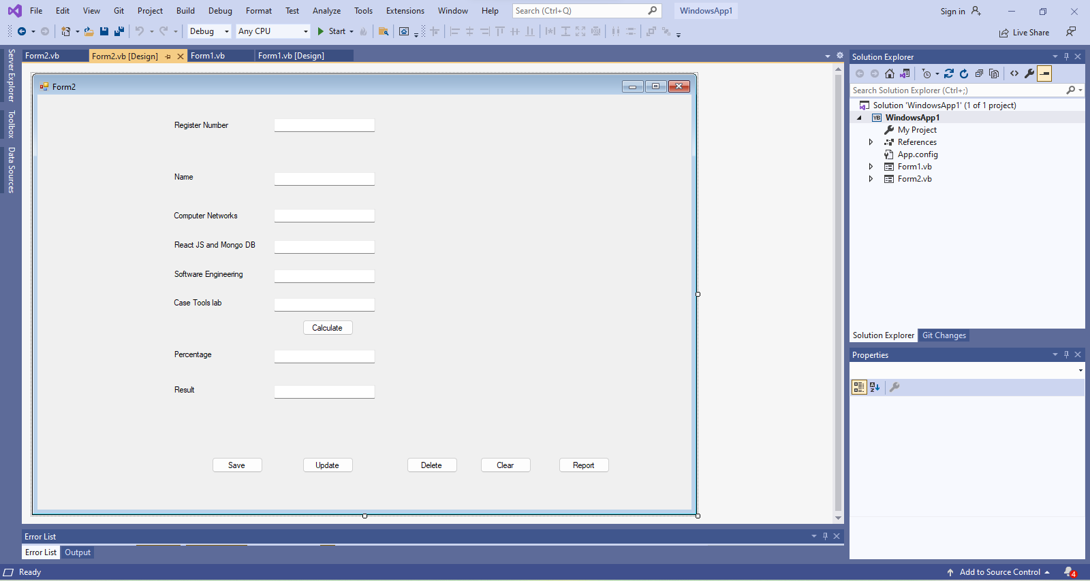

Imports System.Data.SqlClient

Public Class Form2

Private Sub Label8_Click(sender As Object, e As EventArgs) Handles Label8.Click

End Sub

Private Sub Button1_Click(sender As Object, e As EventArgs) Handles Button1.Click

Dim tot As Integer

tot = Val(TextBox3.Text) + Val(TextBox4.Text) + Val(TextBox5.Text) + Val(TextBox6.Text)

TextBox7.Text = (tot / 400) * 100

If (Val(TextBox3.Text) <= 40 Or Val(TextBox4.Text) <= 40 Or Val(TextBox5.Text) <= 40 Or Val(TextBox6.Text) <= 40) Then

TextBox7.Text = 0

TextBox8.Text = "Re-appear"

ElseIf (Val(TextBox7.Text) >= 85) Then

TextBox8.Text = "First class with Dist"

ElseIf (Val(TextBox7.Text) >= 60 And Val(TextBox7.Text) < 85) Then

TextBox8.Text = "First clas"

ElseIf (Val(TextBox7.Text) >= 50 And Val(TextBox7.Text) < 60) Then

TextBox8.Text = "Second Class"

ElseIf (Val(TextBox7.Text) >= 40 And Val(TextBox7.Text) < 50) Then

TextBox8.Text = "Third Class"

Else

TextBox7.Text = 0

TextBox8.Text = "Re-appear"

End If

End Sub

Private Sub Button2_Click(sender As Object, e As EventArgs) Handles Button2.Click

Try

Dim oc As SqlConnection

Dim da As SqlDataAdapter

Dim dt As DataTable

oc = New SqlConnection()

dt = New DataTable()

oc.ConnectionString = "Data Source=22CTIT14;Initial Catalog=studentdb;User ID=sa;Password=sql"

oc.Open()

Dim str As String = "insert into STU(REGNO,NAME,CN,REACT,SE,CASETOOLSLAB,percentage,result)values('" + TextBox1.Text + "','" + TextBox2.Text + "','" + TextBox3.Text + "','" + TextBox4.Text + "','" + TextBox5.Text + "','" + TextBox6.Text + "','" + TextBox7.Text + "','" + TextBox8.Text + "')"

da = New SqlDataAdapter(str, oc)

da.Fill(dt)

MessageBox.Show("Records Inserted")

Call Button4_Click(sender, e)

oc.Close()

Catch ex As Exception

MessageBox.Show(ex.Message.ToString())

End Try

End Sub

Private Sub Button3_Click(sender As Object, e As EventArgs) Handles Button3.Click

Try

Dim oc As SqlConnection

Dim da As SqlDataAdapter

Dim dt As DataTable

oc = New SqlConnection()

dt = New DataTable()

oc.ConnectionString = "Data Source=CTIT16;Initial Catalog=studentdb;User ID=sa;Password=sql"

oc.Open()

'regno,name,cn,dnet,dbms,cnlab,dnetlab'

Dim str As String = "update STU set NAME= '" + TextBox2.Text + "',CN='" + TextBox3.Text + "',REACT='" + TextBox4.Text + "',SE='" + TextBox5.Text + "',CASETOOLSLAB='" + TextBox6.Text + "'where REGNO ='" + TextBox1.Text + "'"

MessageBox.Show(str)

da = New SqlDataAdapter(str, oc)

da.Fill(dt)

MessageBox.Show("Records Updated")

Call Button4_Click(sender, e)

oc.Close()

Catch ex As Exception

MessageBox.Show(ex.Message.ToString())

End Try

End Sub

Private Sub Button4_Click(sender As Object, e As EventArgs) Handles Button4.Click

Try

Dim oc As SqlConnection

Dim da As SqlDataAdapter

Dim dt As DataTable

oc = New SqlConnection()

dt = New DataTable()

oc.ConnectionString = "Data Source=CTIT16;Initial Catalog=studentdb;User ID=sa;Password=sql"

oc.Open()

Dim str As String = "delete from STU where REGNO='" + TextBox1.Text + "'"

da = New SqlDataAdapter(str, oc)

da.Fill(dt)

MessageBox.Show("Records Deleted")

Call Button4_Click(sender, e)

oc.Close()

Catch ex As Exception

MessageBox.Show(ex.Message.ToString())

End Try

End Sub

Private Sub Button5_Click(sender As Object, e As EventArgs) Handles Button5.Click

TextBox1.Text = ""

TextBox2.Text = ""

TextBox3.Text = ""

TextBox4.Text = ""

TextBox5.Text = ""

TextBox6.Text = ""

TextBox7.Text = ""

TextBox8.Text = ""

End Sub

Private Sub Button6_Click(sender As Object, e As EventArgs) Handles Button6.Click

report.Show()

End Sub

End Class

